# Dedicated to My beloved Parents,

**Lecturers and Friends……..**



**CONTENTS**

Abstract

1. Introduction
   1. Problem Definition
   2. About Project
2. Project Analysis
   1. Existing System

2.2Proposed system

1. System Requirements
   1. Hardware Requirements
   2. Software Requirements
2. System Design
   1. Data Flow Diagram
   2. E-R Diagram

### 5.Testing Result and Analysis

1. Conclusion
2. Future Enhancements
3. References

**ABSTRACT**

The Online Voting System is a web based application. The system has a centralized database to keep records of all the Voters and Candidates and Final Results. This Online Voting System is based on **SMS** sending to voters, to confirmation of Vote. This web based system is time saving, work load reduced information available at time and it provide sequrity for the data. During the election, the election commission of India has introduced a new method of polling by online voting system (OVS). The election commission will maintain this website. This is a simple, safe and secure method that takes minimum of time.

The word **VOTE** means to choose from a list, to elect or to determine. The main goal of voting (in a scenario involving the citizens of a given country) is to come up with leaders of the people’s choice. Most countries, India not an exception have problems when it comes to voting. Some of the problems involved include ridging votes during election, insecure or inaccessible polling stations, inadequate polling materials and also inexperienced personnel.

### INTRODUCTION

* 1. **Problem Definition**

The existing manual Voting system consumes more time for Vote Casting. Voter has to wait for vote polling station to vote for a right candidate. The election officers has to be check the voter , this voter can vote in this booth then chek voterID present in voters list of booth those are information will be present then the voter can vote in that booth. The voter had to stand in the queue to cast his vote. All the work is done in paper ballot so it is very hard to locate a particular candidates, some voters cast their votes for all candidates. To overcome of all these problems we have to implement a web application, which is helpful for Voting from any where.

### About Project

The objective of the system is a replacement of the traditional system that is in existence. This smart system reduces the time for voting and also the system is reliable, and faster. In this system the voter username and password will be sent through SMS. The voter cast their vote enter the confirmation OTP sent their mobile number . Database maintained by this system usually contains the Voters information, Candidate information, The final Result of total votes.

### PROJECT ANALYSIS

* 1. **Existing System**

The voting system currently being used by the association is a paper based system, in which the voter simply picks up ballots sheets from electoral officials, tick off who they would like to vote for, and then cast their votes by merely handing over the ballot sheet back to electoral official.

The electoral officials gather all the votes being cast into a ballot box. At the end of the elections, he electoral officials converge and count the votes cast for each candidate and determine the winner of each election category.

### Proposed System

Here we are proposing an web application for voting process that is Online Voting System through SMS. The online voting system will manages the voter’s deatils,Candidate details. The main feature of the project includes voters information and candidate information, voter can login and use his/her voting rights. The system can manage the information data very efficiently. The proposed system is more reliable, faster, accurate and easy to handle compared to existing manual system. It helps to computerize everything and reducing the errors as compare to manual voting system

### SYSTEM REQUIREMENTS

* 1. **Hardware Requirements**
     + Processor: Pentium
     + RAM: 4GB
     + Hard Disk: 1TB
     + Speed: 1.1GHz

### Software Requirements

* + - Operating System: Windows
    - Scripting Language: JSP
    - Back-End: PHP .
    - Front-End: HTML and CSS
    - Supporting Tools: XAMPP(PHP,MYSQL)
    - Type: Web Application.
    - Server: Aache

### 4.SYSTEM DESIGN

#### 4.1 Data Flow Diagram

The data flow diagram(DFD) is a graphical tool used for expressing system requirements in a graphical form. The DFD also known as the “bubble chart” as the purpose of clarification system requirements and identification major transformation that will become program in system design. Thus DFD can be stated as the starting point of the design phase that functionality decomposes the requirements specification down to the lowest level of details. The DFD consists of series of bubble joined by lines. The bubble represents data transformation and the lines represents the data flows in the system. A DFD describes what data flow is does not to construct a Data Flow Diagram, we use

* + - **Arrow:** An arrow identifies the data flow in motion. It is a pipeline through which information is flow like the rectangle in the flowchart.
    - **Circle:** A circle stands for process that converts data into information
    - **Open End Box:** An open ended box represents a data store, data at rest or a temporary repository of data.
    - **Squares:** A square defines a source or destination of system.
  1. **E-R Diagram**

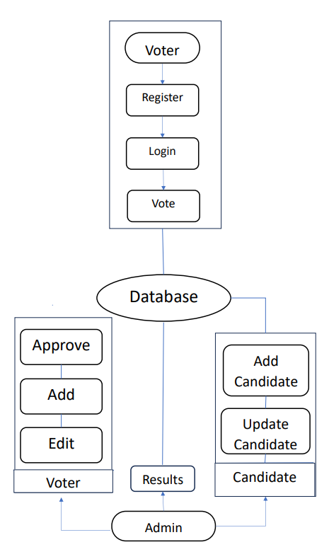

### 5.Testing Result and Analysis

#### Admin Login Page

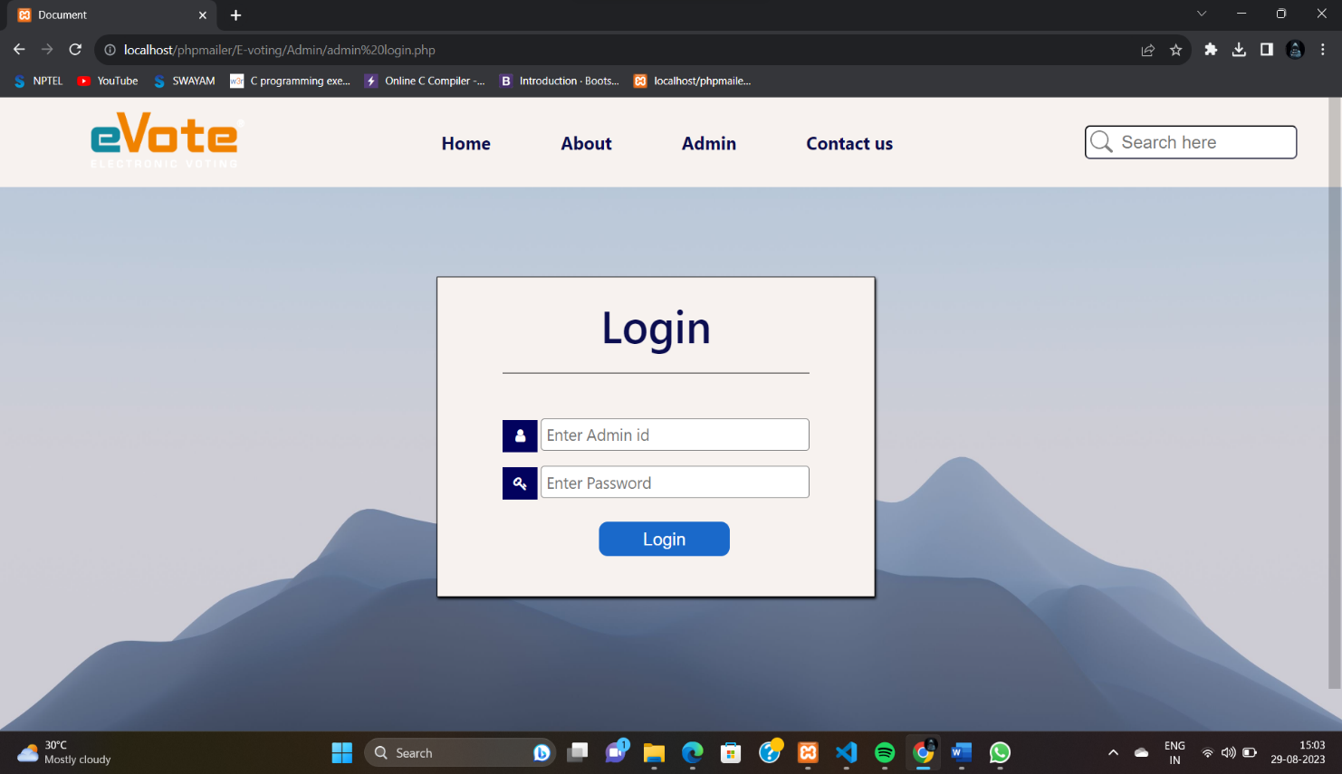

* 1. **Admin dashboard**

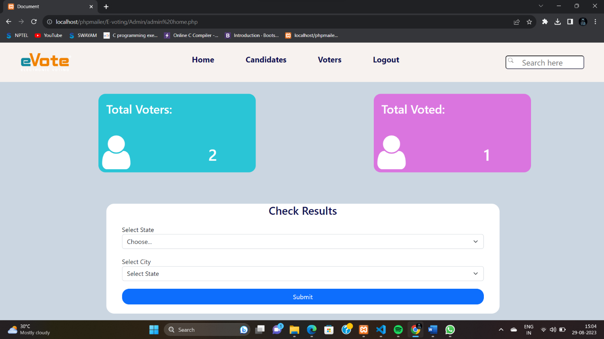

* 1. **Voter Login Page**

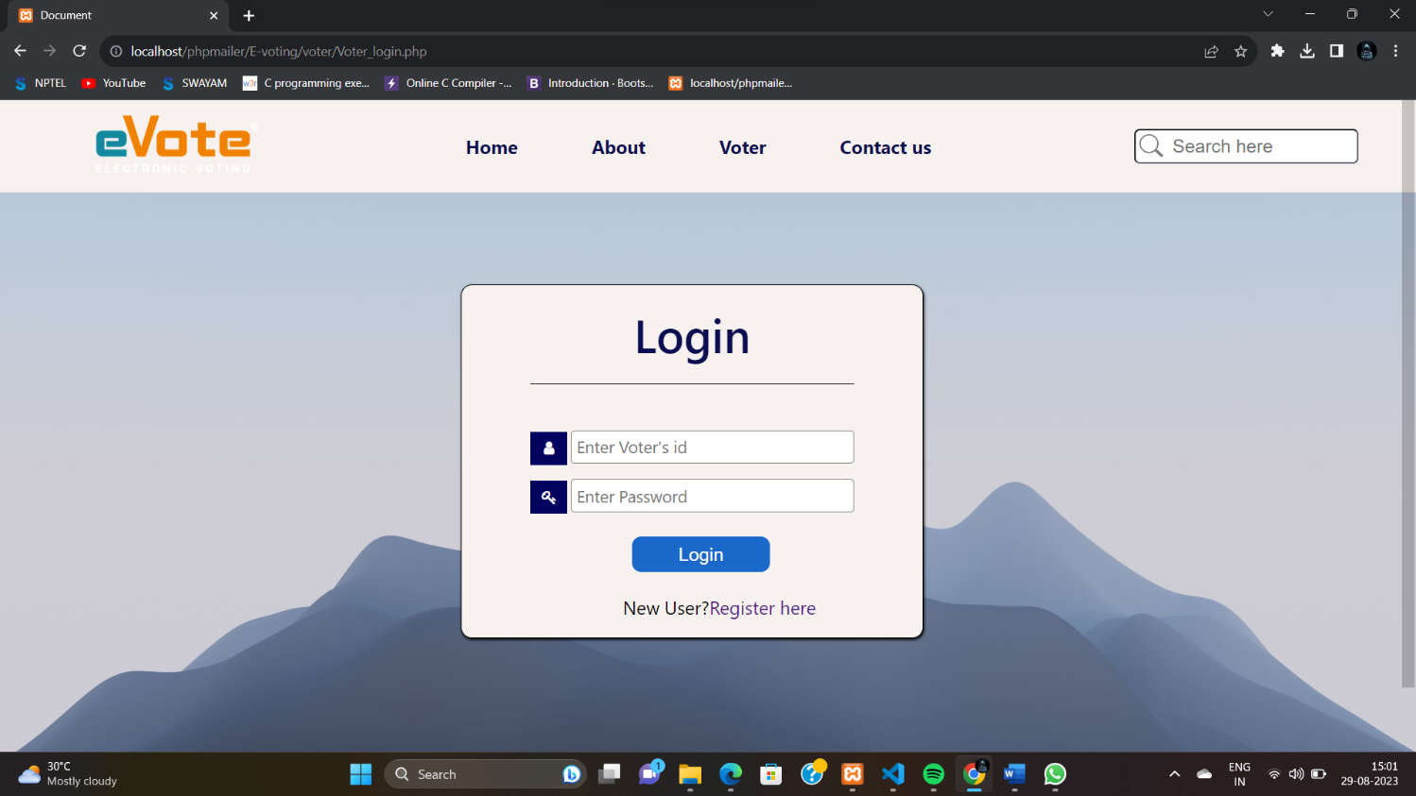

* 1. **Voters Registration Page**

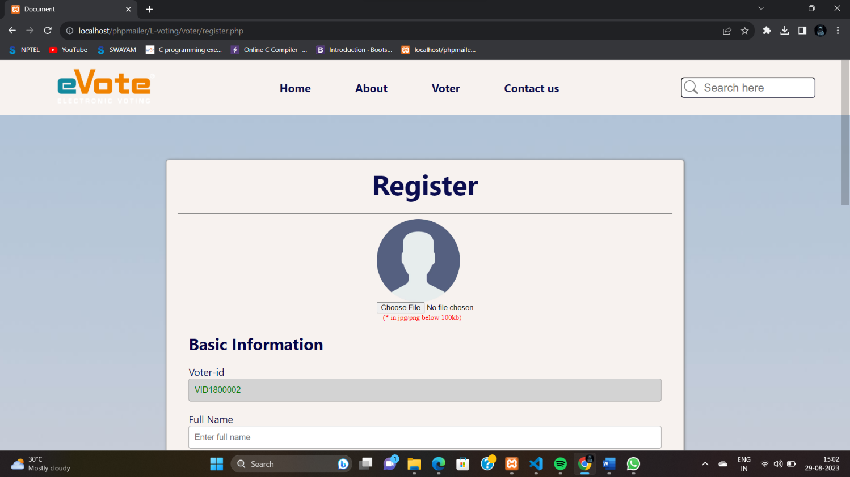

* 1. **Candidate Registration Page**

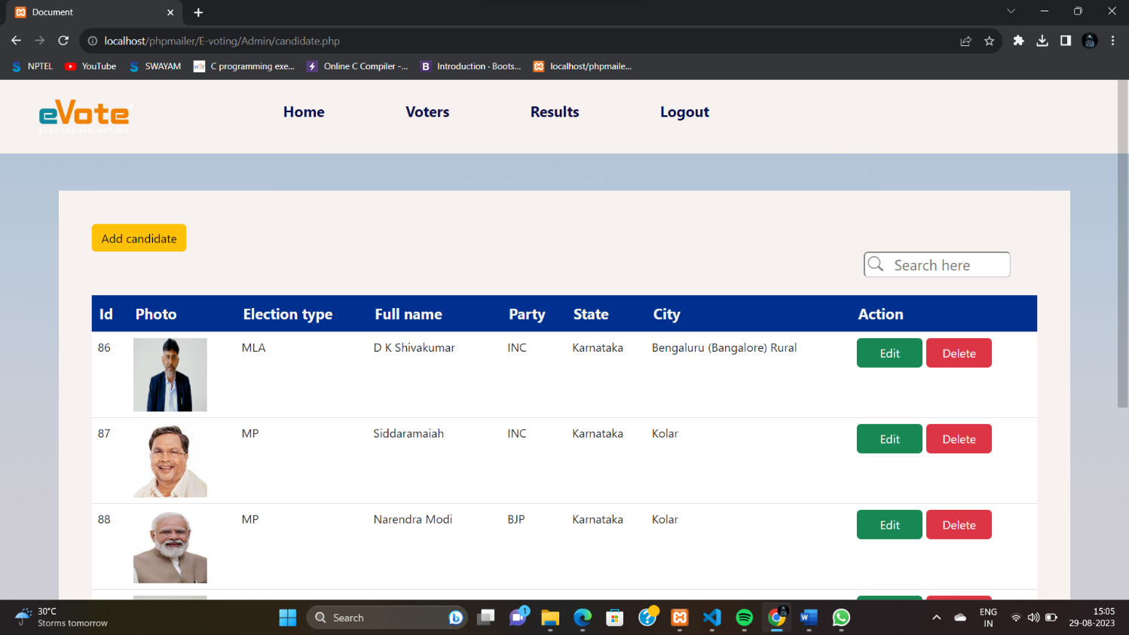

* 1. **Voting status**

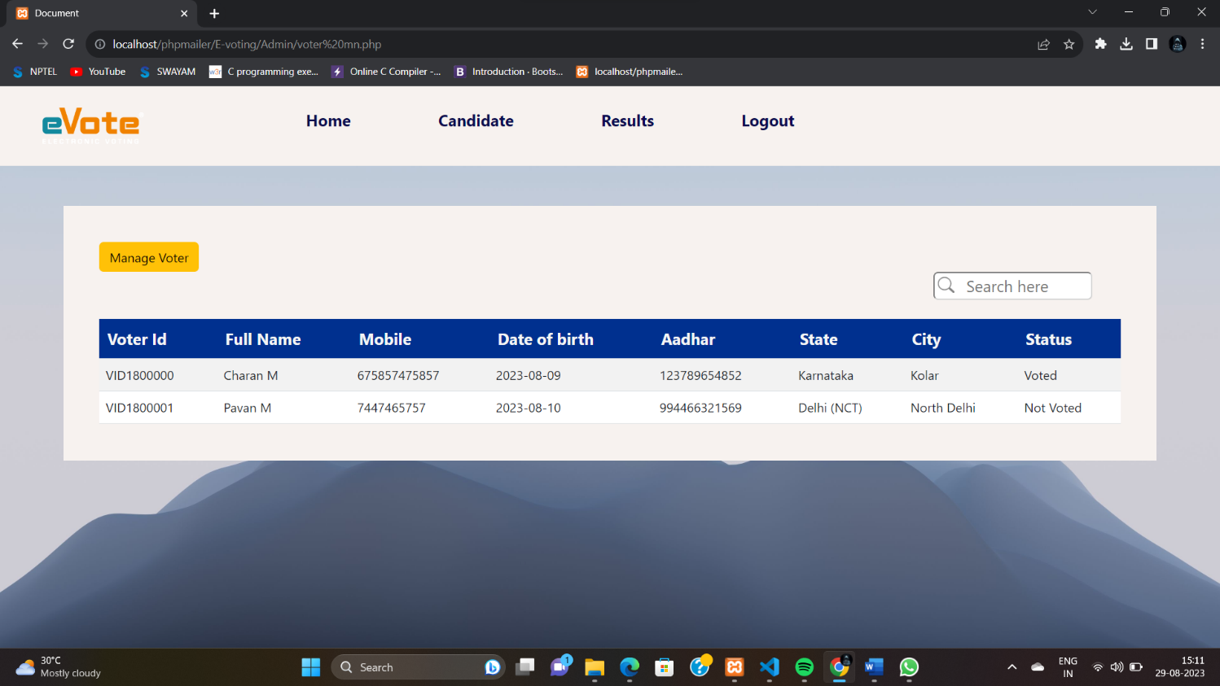

* 1. **Voter information**

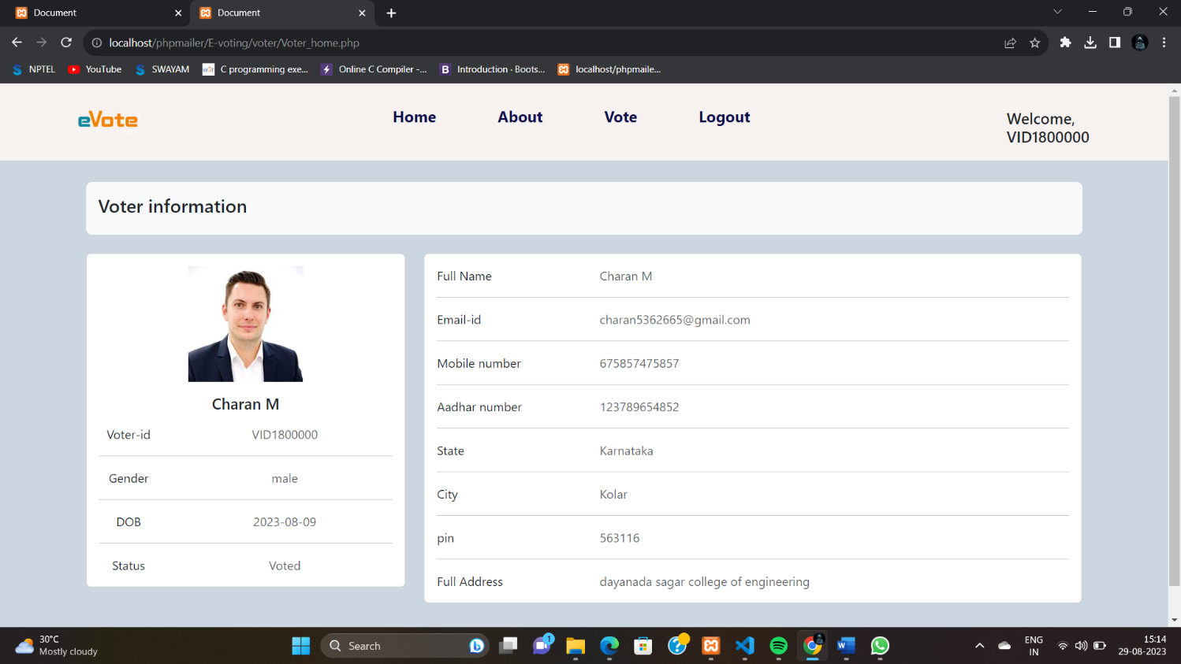

**5.8 Voting page**

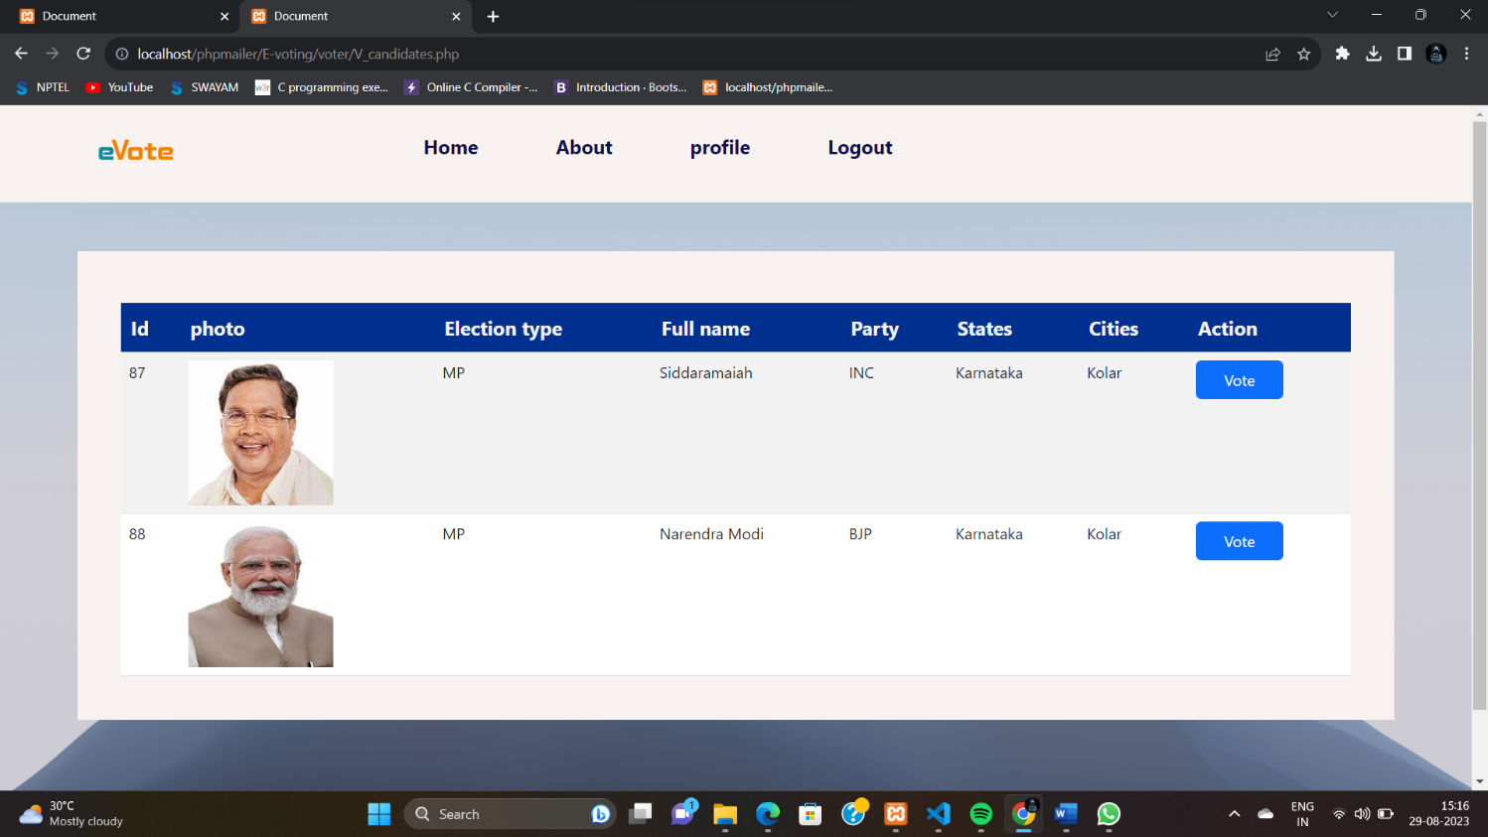

.

### 6. CONCLUSION

This online Voting system will manage the Voter’s information by which voter can login and use his voting rights. The system will incorporate all features of voting system. It provides the tools for maintaining voter’s vote to every party and it count total no. of every party. There is a DATABASE which is maintained by the ELECTION COMMISION OF INDIA in which all the names of voter with complete information is stored.

In this user who is above 18years’s register his/her information on the database and when he/she want to vote he/she has to login by his id and password and can vote to any party only single time. Voting detail store in database and the result is displayed by calculation. By online voting system percentage of voting is increases. It decreases the cost and time of voting process. It is very easy to use and it is very less time consuming. It is very easy to debug.

The traditional method of manual voting system has few drawbacks. This method is obviously not efficient as it wastes the voter’s energy and quite slow in term of completion. This smart system involves the voter’s can cast their vote easily, and can be implemented to the entire India.

### FUTURE ENHANCEMENT

We can use block-chain technology to enhace the security and ensure transparency , and store the information confidentially .

### REFERENCES

1. https://[www.w3schools.com](http://www.w3schools.com/)
2. <https://www.electionsonline.com/online-voting-system/>
3. https://en.wikipedia.org/wiki/Electronic_voting

